CS278 ASSIGNMENT #5: Loops and Arrays

NAME: DUE: Oct 25 Received: .
GRADE:
CATEGORY | POINTS
EX05_01_Convert |  | 10
EX05_02_Exchange |  | 20
EX05_03_Fibonacci |  | 20
EX05_04_Reverse_String |  | 25
EX05_05_Shift_Array |  | 25
TOTAL |  | 100

EXERCISES:

- For ALL of these exercises, you will need the Debugger to verify that your code is working correctly.
- Secondly, your MUST document your code. Describe the approach your code is taking, how it's doing what it's doing. Up to 5 points per problem may be deducted if you don't describe what you are doing in a way that someone else reading your code can understand what your code is doing.
- One suggestion is to document your code with the equivalent C++ syntax (e.g. if statements, for loop, etc.)
- You MUST use indenting to format loops so that we can follow your code. Make loop and variable labels descriptive.
EX05_01_Convert – Do Programming Exercises Problem 4.10.1 on page 137
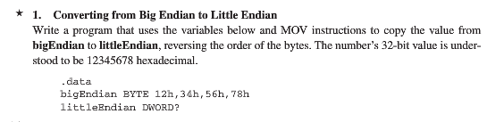
EX05_02_Exchange – Do Programming Exercises Problem 4.10.2 on page 137
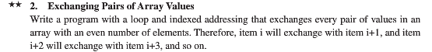
EX05_03_Fibonacci – Do Programming Exercises Problem 4.10.5 on page 138
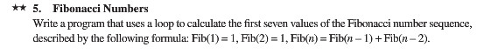
EX05_04_Reverse_String – Do Programming Exercises Problem 4.10.7 on page 138
NOTE: This is the one in class! See the slides. You may do this one in pairs; just acknolwedge all the team members.
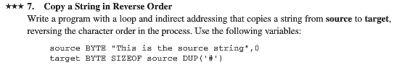

EX05_05_Shift_Array – Do Programming Exercises Problem 4.10.8 on page 138
